UAT Plan

for

Biomedical Engineering

Index

1. Scope 3

1.1. Objectives and business requirements 3

1.2. Scope 3

1.3. System Diagrams 3

2. Testing team 5

3. Test Scripts 1

# Scope

## Objectives and business requirements

The goal of this user acceptance test is to ensure that all the features of the TriClaw work as intended.

## Scope

The TriClaw should be able to detect the colour of the piece picked up and the colour of the board below it.

*For this UAT test, we’d like to:*

* *If the TriClaw correctly responds to the right colour piece*
* *If the TriClaw can seamlessly switch between which colour the TriClaw responds to*

*For the UAT test, we are not testing:*

* *If the TriClaw suits David’s needs - (This is just a prototype being tested and the actual version will be tested to see if it suits David’s needs)*

## System Diagrams

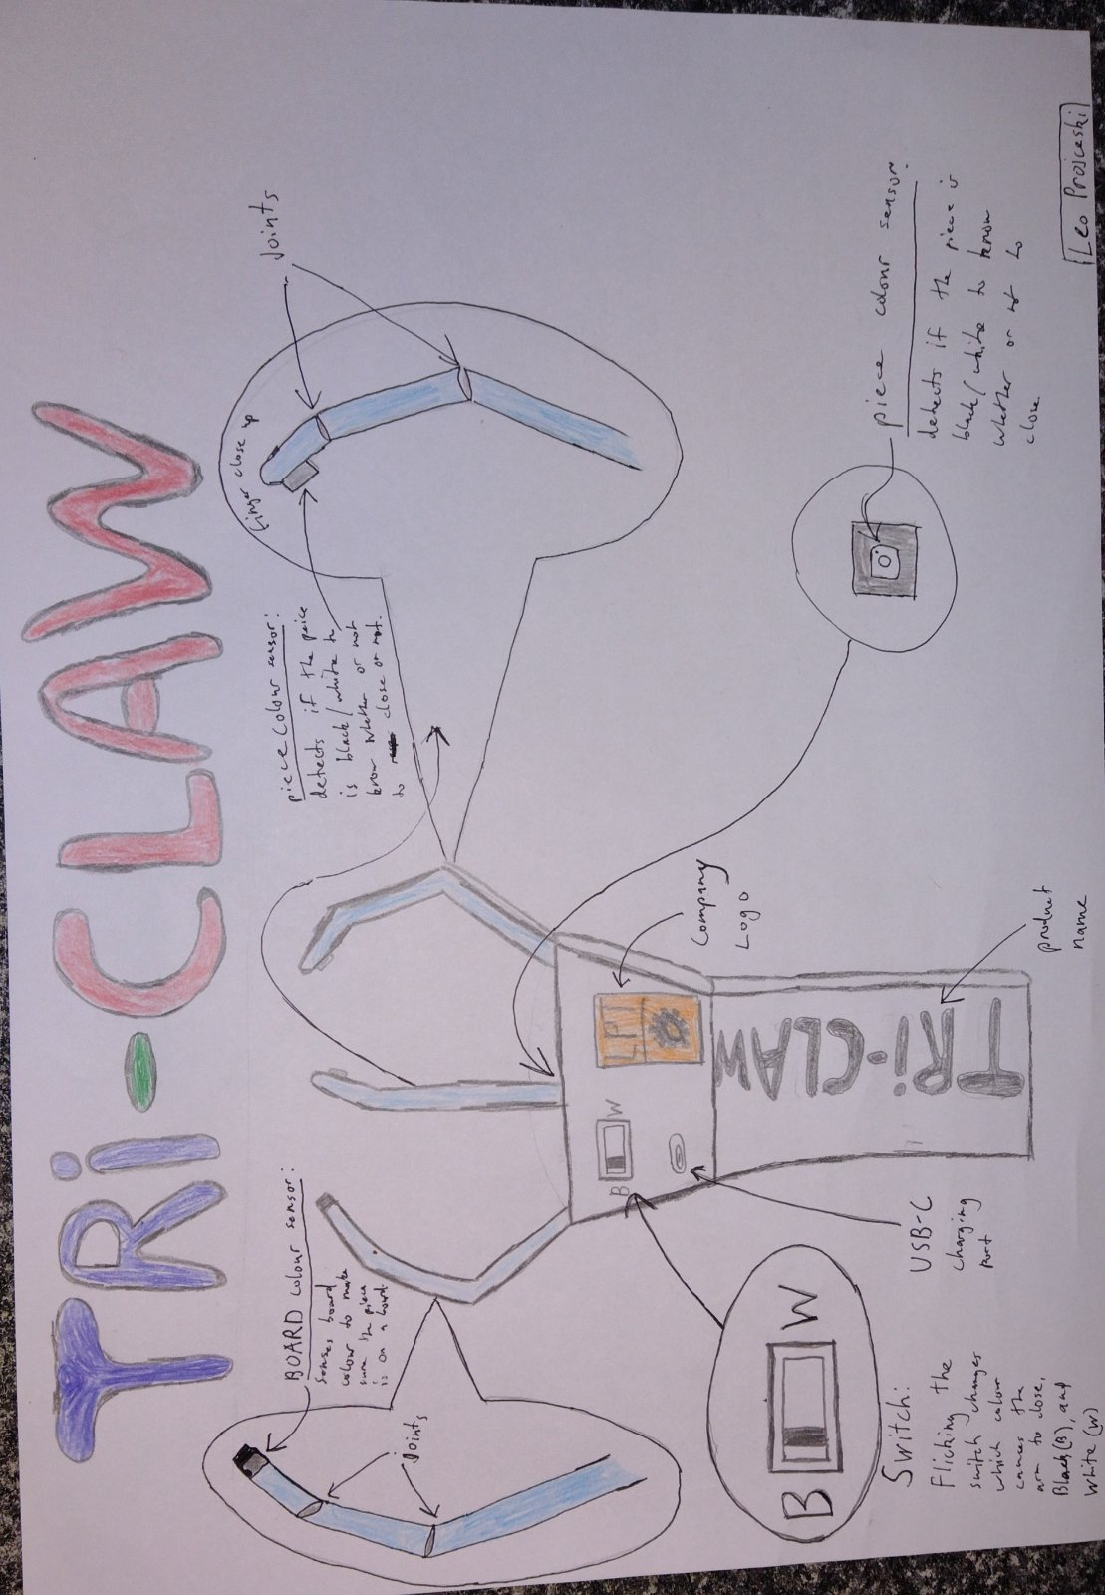

# Testing team

In this section, list out members of your QA team and what their roles will be during UAT.

Example:

| **Name** | **Responsibilities** |
| --- | --- |
| David | Test the features on the TriClaw. |
| Leo Projceski | Test code of the TriClaw. |

# Test Scripts

This section is more important than it seems—it is crucial that both the QA team and the testers know what features must be tested, especially if you’re testing a lot at once.

| **Test** | **Describe the feature being tested** | **Describe the user input or test data** | **Describe the pass criteria** |  |
| --- | --- | --- | --- | --- |
| 1.1 | Test if black piece recognition works | 1. David holds the TriClaw above a black piece on the board 2. David puts the TriClaw on top of the piece and waits for it to close 3. David places the piece where he wants and waits for the TriClaw to open after 3 seconds of it picking up the piece | 1. The TriClaw closes on the piece when it detects the right colour. | Tester name: David   |  | PASS | | --- | --- | |  | FAIL |   Observations: |
| 1.2 | Test is black piece recognition works | 1. David holds the TriClaw above a white piece on the board 2. David puts the TriClaw on top of the piece and waits for it to close 3. David places the piece where he wants and waits for the TriClaw to open after 3 seconds of it picking up the piece | 1. The TriClaw closes on the piece when it detects the right colour. | Tester name: David   |  | PASS | | --- | --- | |  | FAIL |   Observations: |
| 1.3 | TriClaw detects board colour | 1. TriClaw detects board colour. 2. When TriClaw detects white/black, the TriClaw closes for 3 seconds | 1. The TriClaw closes when it detects the white/black board. | Tester name:   |  | PASS | | --- | --- | |  | FAIL |   Observations: |